**Day 1 1st Session: Brainstorming**

1. Your Thesis Statement:

**Your team is on behalf of the city of ________________ to prompt its tourism.**

1. Brainstorm:

**Think of information that you would like to introduce to the audience.**

1. Classify the information to establish a hierarchy:

**Your team is on behalf of the city of ________________ to prompt its tourism.**

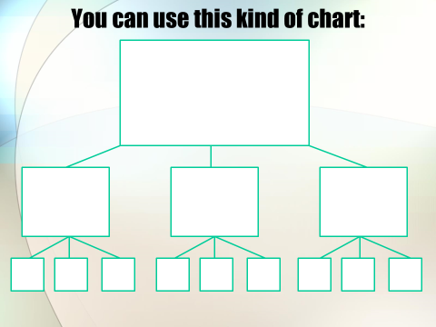

**Day 1 2nd Session: Outlining**

1. Plan you Outline

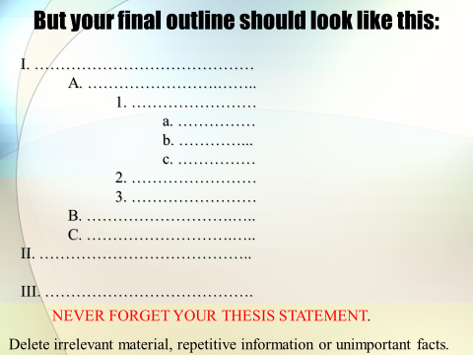

-------------------------------------------**OUTLINE-**-----------------------------------------

\

**Day 2 1st Session: Body Content**

1. Discuss on PPT Slides & Workload:

**Your team is on behalf of the city of ________________ to prompt its tourism.**

**Structure of a Presentation**

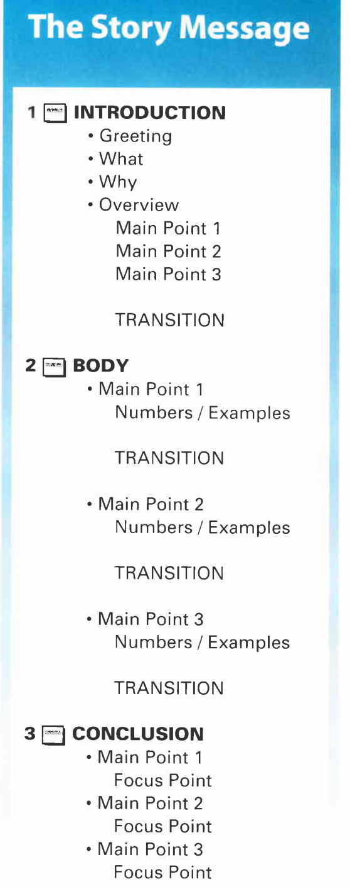

**Introduction Preparation**

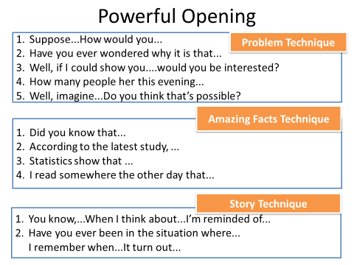

Greeting

* Good morning/ afternoon ladies and gentlemen…

Subject

* I plan to say a few words about…
* I’m going to talk about …
* The subject of my talk is ….
* the theme of my presentation is …
* I’d like to give you an overview of …

Structure

* I’ve divided my talk into ____ parts.
* My talk will be in _____ parts.
* I’m going to divide…
* First/ In the first part…
* Second/ Then in the second part…
* Third…
* Finally….

Length

* My talk will take about ______ minutes.
* The presentation will take about _____ hours…, but there’ll be a _____ minute break in the middle. We’ll stop for break at ______.

Policy on question/ discussion

* Please interrupt if you have any questions.
* After my talk there’ll be time for a discussion and any questions.

**Body Preparation**

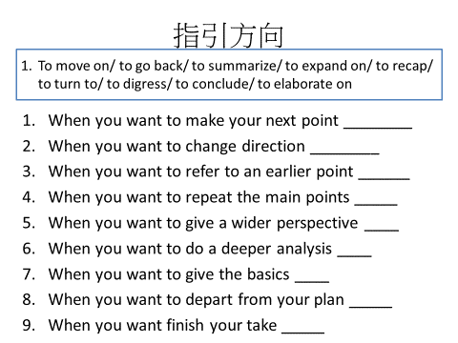

Shifting to the Next Main Point

* Well, let's move on to the next point.
* We will now come to the second problem.
* Turning to the next question, I' 11 talk about the stages of the procedure.
* As the second topic, I shall stop here. Now let' s turn our attention to the third topic.
* So much for the methodology of our experiment. I would now like to shift to the discussion of the results.
* Now, let's move away from the first part and switch over to the next part of my presentation.
* That's all for the introduction and now we can go on to the literature review.
* Next, I would like to turn to a more difficult problem.
* The next point I'd like to talk about is the feasibility of this project.
* That brings me to my second point.
* I am glad that we can now leave this rather boring subject of mathematic deduction and go into a more attractive one, that is the application of the formula.

Resuming the Topic

* Let' s come back to what I said in the first part of my speech.
* Getting back to the subject of the problem of theoretical considerations we can find that...
* I want to return to the first part of my presentation.
* Now, to get back to the effect of temperature, you may be aware that the problems have been solved.
* This brings me back to the question of security.
* At this point I would like to refer again to the question of methods in the first part of my lecture.
* Referring again to the first question, I think...
* Referring to the Coming Point
* I'll deal with it later.
* I' 11 touch upon that point in a moment.
* I shall tell you in detail shortly.

Introducing the Supporting Materials

* I think this part is the most difficult, so I'll explain it in greater detail.
* I think this part of my paper is most important, so I plan to spend more time on it.
* Please allow me to deal with this matter more extensively.
* Being the most important part of my presentation, I will elaborate on it with more slides.
* I' 11 expand this topic with drawings and figures.
* Indicating the Points Briefly
* Limited by the time available, I can only give you a very brief account of this matter.
* I don't think that I should describe the methods in detail, because they are included in the handout.
* I will not go into detail on it.
* This point has been talked about repeatedly in this symposium, so I am not going to spend too much time on it.
* Let's go through the following points very rapidly.
* I just want to outline for you what I experienced in using this new drug.
* I shall not go over all these explanations. My time is running short. So I'’11 be brief.
* It is sufficient to say that these experiments were poorly designed and without controls.

Expressions Concerning Audio-Visual Aids

* Could we have the lights off? And the first slide, please.
* Lights off, first slide, please.
* Dim the lights, and first slide, please.
* The slide is not so clear. Please darken the room a little more.
* Could you please turn on the lights, please?
* Now, we can have the lights on.
* Please switch on the lights.
* Lights on, please.
* I apologize that this slide is not so clear, but I hope you can still make out the general idea.
* Sorry for the small print.
* I'm sorry we left a figure out here.

Explaining the Contents on the Slides

This slide demonstrates ...

On this slide, you can see...

This curve in this slide shows...

This figure in this slide exhibits...

This table on this slide presents...

This diagram on this slide depicts...

This chart on this slide displaces ...

The picture on this slide shows ...

The photomicrograph on this slide shows ...

The flow-chart on this slide points out...

The circuit diagram on this slide represents~...~

Indicating the Sources of the Content in a

This figure is taken from.., by Dr. Li.

This diagram is after that of Prof. Wang with some modification

VII. Demanding to Show the Next Slide

May I proceed to the next slide, please?

I think we can move on to the next slide.

Let me show you the next slide.

Now, we can go on to the next slide. '

Next slide, please.

Next, please.

Next !

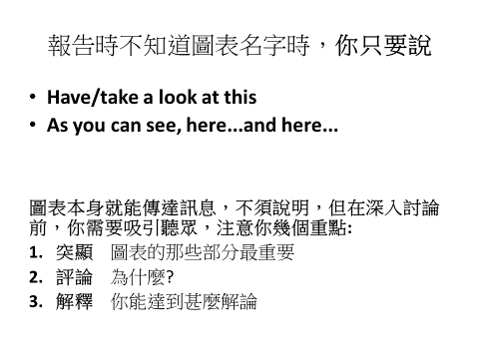

**Conclusion Preparation**

* In conclusion, I'd like to...
* I'd like to finish by...
* Finally...
* By way of conclusion...
* I hope I have made myself understood
* I hope you have found this useful
* I hope this has given you some idea/clear idea/an outline of...
* Let me end by saying...
* That, then was all I had to say on...
* That concludes our presentation...
* I hope I've managed to give you a clearer picture of...
* If there are any questions, I'd be delighted to...
* Thank you for your attention...
* Let's break for a coffee at this point
* I am afraid that the clock is against us, so we had better stop here
* You have been a very attentive audience---thank you